The laboratory work 4

Navigation in a Multi-Page Xamarin.Forms Application

Update the app with Visual Studio
- Launch Visual Studio. In the start window, click the Notes solution in the recent projects/solutions list, or click Open a project or solution, and in the Open Project/Solution dialog select the solution file for the Notes project:
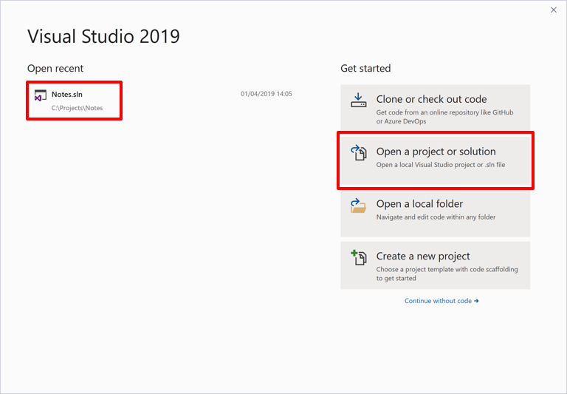
- In Solution Explorer, right-click on the Notes project and select Add > New Folder:
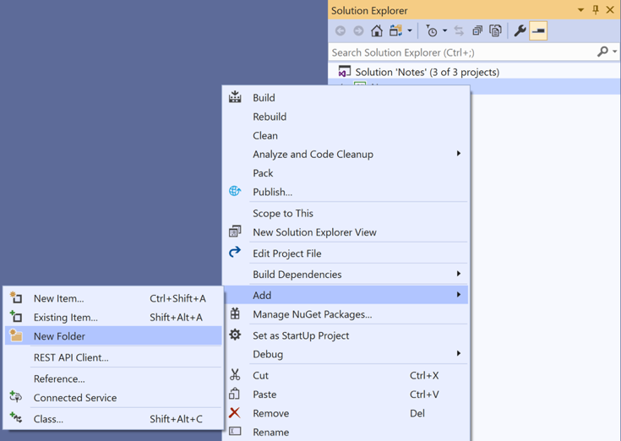
- In Solution Explorer, name the new folder Models:
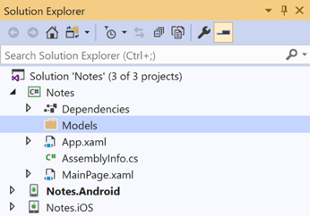
- In Solution Explorer, select the Models folder, right-click, and select Add > New Item...:
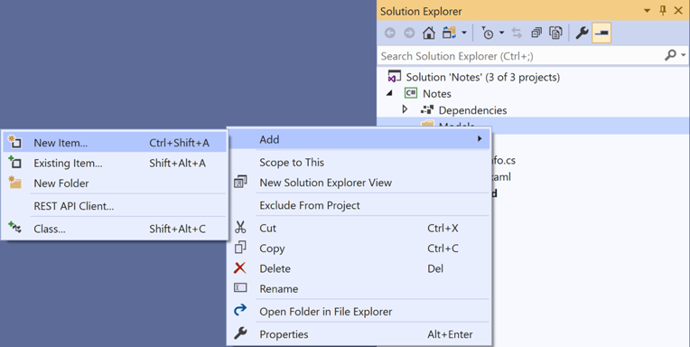
- In the Add New Item dialog, select Visual C# Items > Class, name the new file Note, and click the Add button:
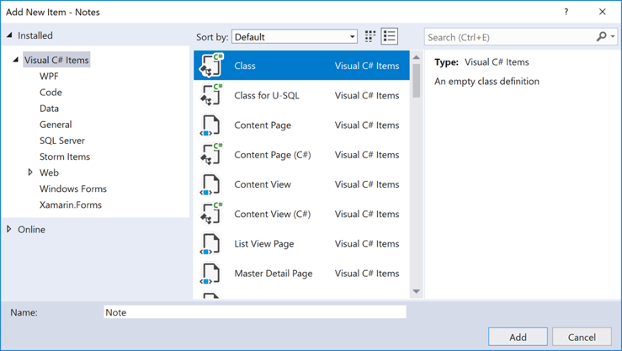
This will add a class named Note to the Models folder of the Notes project.
- In Note.cs, remove all of the template code and replace it with the following code:
using System;

namespace Notes.Models
{
public class Note
{
public string Filename {get; set;}
public string Text {get; set;}
public DateTime Date {get; set;}
}
}
- This class defines a Note model that will store data about each note in the application.
Save the changes to Note.cs by pressing CTRL+S, and close the file.
- In Solution Explorer, right-click on the Notes project and select Add > New Item... In the Add New Item dialog, select Visual C# Items > Xamarin.Forms > Content Page, name the new file NoteEntryPage, and click the Add button:
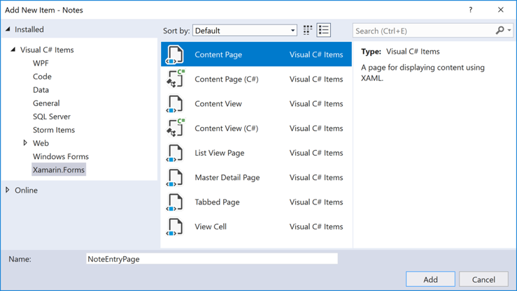
This will add a new page named NoteEntryPage to the root folder of the project. This page will be the second page in the application.
- In NoteEntryPage.xaml, remove all of the template code and replace it with the following code:
<?xml version="1.0" encoding="UTF-8"?>
<ContentPage xmlns="http://xamarin.com/schemas/2014/forms"
xmlns:x="http://schemas.microsoft.com/winfx/2009/xaml"
x:Class="Notes.NoteEntryPage"
Title="Note Entry">
<StackLayout Margin="20">
<Editor Placeholder="Enter your note"
Text="{Binding Text}"
HeightRequest="100" />
<Grid>
<Grid.ColumnDefinitions>
<ColumnDefinition Width="*" />
<ColumnDefinition Width="*" />
</Grid.ColumnDefinitions>
<Button Text="Save"
Clicked="OnSaveButtonClicked" />
<Button Grid.Column="1"
Text="Delete"
Clicked="OnDeleteButtonClicked"/>
</Grid>
</StackLayout>
</ContentPage>

This code declaratively defines the user interface for the page, which consists of an Editor for text input, and two Button instances that direct the application to save or delete a file. The two Button instances are horizontally laid out in a Grid, with the Editor and Grid being vertically laid out in a StackLayout. In addition, the Editor uses data binding to bind to the Text property of the Note model. For more information about data binding, see Data binding in the Xamarin.Forms Quickstart Deep Dive.
Save the changes to NoteEntryPage.xaml by pressing CTRL+S, and close the file.
- In NoteEntryPage.xaml.cs, remove all of the template code and replace it with the following code:
using System;
using System.IO;
using Xamarin.Forms;
using Notes.Models;

namespace Notes
{
public partial class NoteEntryPage : ContentPage
{
public NoteEntryPage()
{
InitializeComponent();
}

async void OnSaveButtonClicked(object sender, EventArgs e)
{
var note = (Note)BindingContext;

if (string.IsNullOrWhiteSpace(note.Filename))
{
// Save
var filename = Path.Combine(App.FolderPath, $"{Path.GetRandomFileName()}.notes.txt");
File.WriteAllText(filename, note.Text);
}
else
{
// Update
File.WriteAllText(note.Filename, note.Text);
}

await Navigation.PopAsync();
}

async void OnDeleteButtonClicked(object sender, EventArgs e)
{
var note = (Note)BindingContext;

if (File.Exists(note.Filename))
{
File.Delete(note.Filename);
}

await Navigation.PopAsync();
}
}
}
This code stores a Note instance, which represents a single note, in the BindingContext of the page. When the Save Button is pressed the OnSaveButtonClicked event handler is executed, which either saves the content of the Editor to a new file with a randomly generated filename, or to an existing file if a note is being updated. In both cases, the file is stored in the local application data folder for the application. Then the method navigates back to the previous page. When the Delete Button is pressed the OnDeleteButtonClicked event handler is executed, which deletes the file, provided that it exists, and navigates back to the previous page. For more information about navigation, see Navigation in the Xamarin.Forms Quickstart Deep Dive.
Save the changes to NoteEntryPage.xaml.cs by pressing CTRL+S, and close the file.
- In Solution Explorer, right-click on the Notes project and select Add > New Item... In the Add New Item dialog, select Visual C# Items > Xamarin.Forms > Content Page, name the new file NotesPage, and click the Add button.
This will add a page named NotesPage to the root folder of the project. This page will be the root page of the application.
- In NotesPage.xaml, remove all of the template code and replace it with the following code:
<?xml version="1.0" encoding="UTF-8"?>
<ContentPage xmlns="http://xamarin.com/schemas/2014/forms"
xmlns:x="http://schemas.microsoft.com/winfx/2009/xaml"
x:Class="Notes.NotesPage"
Title="Notes">
<ContentPage.ToolbarItems>
<ToolbarItem Text="+"
Clicked="OnNoteAddedClicked" />
</ContentPage.ToolbarItems>
<ListView x:Name="listView"
Margin="20"
ItemSelected="OnListViewItemSelected">
<ListView.ItemTemplate>
<DataTemplate>
<TextCell Text="{Binding Text}"
Detail="{Binding Date}" />
</DataTemplate>
</ListView.ItemTemplate>
</ListView>
</ContentPage>

This code declaratively defines the user interface for the page, which consists of a ListView and a ToolbarItem. The ListView uses data binding to display any notes that are retrieved by the application, and selecting a note will navigate to the NoteEntryPage where the note can be modified. Alternatively, a new note can be created by pressing the ToolbarItem. For more information about data binding, see Data binding in the Xamarin.Forms Quickstart Deep Dive.
This code declaratively defines the user interface for the page, which consists of a ListView and a ToolbarItem. The ListView uses data binding to display any notes that are retrieved by the application, and selecting a note will navigate to the NoteEntryPage where the note can be modified. Alternatively, a new note can be created by pressing the ToolbarItem. For more information about data binding, see Data binding in the Xamarin.Forms Quickstart Deep Dive.
Save the changes to NotesPage.xaml by pressing CTRL+S, and close the file.
- In NotesPage.xaml.cs, remove all of the template code and replace it with the following code:
This code defines the functionality for the NotesPage. When the page appears, the OnAppearing method is executed, which populates the ListView with any notes that have been retrieved from the local application data folder. When the ToolbarItem is pressed the OnNoteAddedClicked event handler is executed. This method navigates to the NoteEntryPage, setting the BindingContext of the NoteEntryPage to a new Note instance. When an item in the ListView is selected the OnListViewItemSelected event handler is executed. This method navigates to the NoteEntryPage, setting the BindingContext of the NoteEntryPage to the selected Note instance. For more information about navigation, see Navigation in the Xamarin.Forms Quickstart Deep Dive.
In Solution Explorer, double-click App.xaml.cs to open it. Then replace the existing code with the following code:
using System;
using System.IO;
using Xamarin.Forms;

namespace Notes
{
public partial class App: Application
{
public static string FolderPath {get; private set;}

public App()
{
InitializeComponent();
FolderPath = Path.Combine(Environment.GetFolderPath(Environment.SpecialFolder.LocalApplicationData));
MainPage = new NavigationPage(new NotesPage());
}
// ...
}
}
- This code adds a namespace declaration for the System.IO namespace, and adds a declaration for a static FolderPath property of type string. The FolderPath property is used to store the path on the device where note data will be stored. In addition, the code initializes the FolderPath property in the App constructor, and initializes the MainPage property to be a NavigationPage that hosts an instance of NotesPage. For more information about navigation, see Navigation in the Xamarin.Forms Quickstart Deep Dive.
Save the changes to App.xaml.cs by pressing CTRL+S, and close the file.
- In Solution Explorer, in the Notes project, right-click MainPage.xaml, and select Delete. In the dialog that appears press the OK button to remove the file from your hard disk.
This removes a page that's no longer used.
- Build and run the project on each platform. For more information, see Building the quickstart.
On the NotesPage press the + button to navigate to the NoteEntryPage and enter a note. After saving the note the application will navigate back to the NotesPage.
Enter a number of notes, of varying length, to observe the application behavior.

